Professional European and Worldwide Accounts and Tax Advisors

Expenses, social insurance and your pay

Contents
Training costs as expenses

Your expenses are one of the most important aspects of your company. These are used to reduce your taxable salary each month. You should always try to keep your expense as high as possible and should always upload your receipts to our secure server.
When starting your contract you will be completing your type rating course/line training. In the first instance before you are given a permanent base you should claim for the following:

- When you receive your invoice for the CAE course you should upload this into the OAM web system under expenses – Training courses. We also receive a copy of this and will upload this if you have not done so.
- You should also add in the start and end date of the course into the travel form in the OAM website. You will also have to fill in other fields and the location of the course. When you enter the location of the course the form will automatically calculate the overnight and subsistence rate for you.
You can NOT add in these expenses until you have completed the above. You can NOT add in forward dates on your expense claims.

Example training costs:
CAE Course - €29500
3 months training in EMA Subsistence and overnights – Approximately - €20000
You will have approximately €50,000 in expenses. This should be sufficient for your first 12-18 months of working.

Temporary bases and OOB

Temporary and out of base (OOB) expenses:
After your type rating course you may be assigned a temporary base until you receive your permanent base letter. Whilst you are in a temporary base you are effectively classed as out of base (OOB) and therefore can claim the following travel and subsistence:

- Subsistence and overnights using the travel form on OAM.
- Claim for traveling to and from work by adding mileage into the travel form on OAM.

Permanent base:

When you move to your permanent base you can no longer claim the overnight allowance and subsistence.

You can claim the following:

- Relocation Expenses – For the first 14 days of moving to your permanent base, you can claim the overnight allowance and daily subsistence.
- You can claim the first 3 month’s rent.
- Daily subsistence whilst flying from your HOME BASE by using the OAM daily subsistence form.

Expenses

Expenses for all pilots:
You can claim any reasonable expense if it is directly connected to your contract with your airline. These include the following:

- You are entitled to a subsistence allowance when flying out of your assigned HOME BASE. Go to the Expenses, Travel & Subsistence page - click the daily subsistence tab and add in the days.
- Licence renewal
- Eye test, glasses and sun glasses
- Medical expenses
- Home office – The amount of rent allowed to be claimed (plus utility bills) is now 20% of the total cost of your rented accommodation
- Assessment fee – you can claim this if it is within 3 months of signing with your agency.
- Interest: The interest for any loan taken out for your Type rating course can be added as an expense when you receive your loan statement.
- Loss of License – this is allowable as an expense and should be added in when paid.
- Phone bills – mobile phone costs and internet or broadband connections can be claimed in full. Home phone bills (if paid for by yourself) should be apportioned and one third only claimed.
- Bank charges - These are claimable so please add them in.
- CAE Type rating course
- Line training

Expense for all

- Public transport including Train/Taxi/Dart/Luas
- Subscriptions to journals, magazines
- Client ship of professional organisations
- Seminar and Conferences expenses
- Business mileage & subsistence – both a mileage rate is claimable for journey undertaken for business purposes (these will be the civil service rates as they apply to your car type) and relevant subsistence rates depending on the city you work from whilst ‘out of base’.
- Consumables, Stationery, Postage
- Self-Education Courses
- Pension contributions
- Maximum of 1 Computer or Laptop per year, Office Equipment
- Relocation expenses (If you are relocating to another base to take up a new position)
- Permanent Health Insurance (PHI)
If you are unsure whether you can claim an expense please email info@oconnorandassociates.ie or contact your account manager and they will be able to advise you.

Expenses MUST be uploaded by the 8th of every month to allow these to be used in the payroll for that month.

Your expenses may be audited by the revenue so please be sure you can claim for everything you add to the system. It is your responsibility to ensure these are correct. At any time the revenue may revise the expenses that are allowable.

What you CANNOT claim

Expenses that are NOT allowed:
- You can NOT claim for travelling to and from your HOME BASE.
- You can NOT claim for any parking of vehicles.
- No expenses relating to cars can be claimed except mileage when travelling on out of base trips. This includes registration fees, tax, insurance, interest on finance, repairs etc.
- Car hire.
- You CAN NOT add food, hotel or petrol as a normal expense.
- Standby days cannot be claimed for from your HOME BASE.
- You CAN NOT claim any memberships like gym, swimming or any other leisure type activities as an expenses.
- Your agency’s bank charges cannot be claimed back as they are already tax deductible via your payslip.

Your pay explained

We receive the hours from your agency between the 9th – 11th of each month. We endeavour to transfer your wages on the 14th of each month. Your funds can take up to 3 working days to appear in your bank account from the 14th of the month.

An example of how your pay is calculated is as follows:

First Officer Salary - €5000 approx. per month
Gross Taxable Salary - €1000
Expenses - €5000 - €1000 = €4000 payable as expenses (if you have this amount of expenses available)

Less bank charges - €5
Less Management fee - €100

Net Taxable Salary - €895
€895 @ 20% Income Tax = €179
Less tax credits – €183.33
Nil tax deducted

Universal Social Charge - €895 @ 1% = €8.95
Social Insurance - €895 @ 4% = €35.80
Total tax deductions – €44.75

€895 - €44.75 = €850.25

Net Pay - €850.25 + €4000 = €4,850.25 (97% take home pay)

Your payslip explained

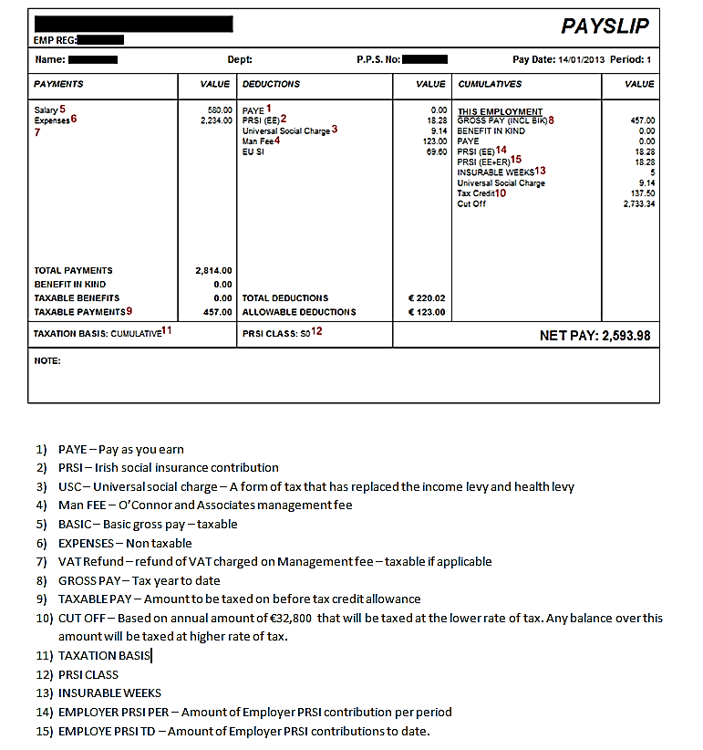
Social Insurance

Social insurance and taxes:

Social Insurance in Europe:
From October 2016, the rate of social insurance applicable will be that which is set by the country in which you are completing your line training. The rate will therefore vary depending on your location.

When you have received your permanent base letter you must send this to us so we can advise you on how to register for social insurance in the country of your base.

We will then set you up to pay the correct social insurance in your permanent base country. At the same time, you will continue to pay your income taxes in Ireland.

Please note that social insurance can rates significantly vary from one country to another and are charged in accordance with EU regulations.

Management fees may be higher in some countries owing to the administrative costs associated with registering companies/individuals for social insurance.

This refers to the Irish rate of social insurance (PRSI). From October 2016, the rate of social insurance applicable will be that which is charged by the country in which you are completing your line training. It % charged will therefore vary depending on your location.

